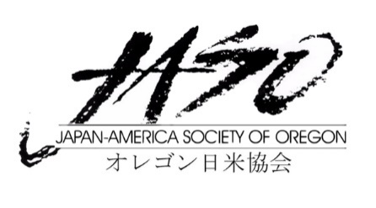 勉強会 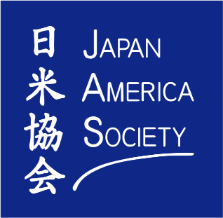

JAS Oregon and JASSC application forms for the Japan Bowl Benkyoukai are officially available for students to apply! We are looking forward to meeting all of your highly motivated students ready to join our fun and competitive sessions! There are a few important things that I’d like to share regarding the registration process.

- The Application Deadline: January 15th, 2021

We only need students to submit this application form digitally. After we receive their application, we will review each eligible candidate. However, Due to a limitation of space, applications will be accepted on a first come first serve basis. Before we make our applications widely available on our website, both JAS Oregon and JASSC wanted to give our local schools and their students priority for this exciting event! So we highly encourage students to submit their applications before Dec. 31st when our website goes live.**

- The Payment Deadline (with physical copy of application): Feb 5th, 2021

Students must pay a $10 registration fee unless you are a Level 2 observer or an observing teacher. We will send a payment link once your application has been accepted. We also ask that students mail in their physical copy of their application forms to our address.

- Where to apply!

Level 3 students please select the JAS Oregon’s application.
Level 4 students please select the JAS of Southern California application.

**Email links for students to submit their forms will be provided in the application**

Please see below for the details on the Program:

Proposed Schedule of Sessions (Dates are tentative)
Friday, March 5, 2021 5PM-6:30PM – Session #1
Friday, March 12, 2021 5PM-6:30PM – Session #2
Friday, March 19, 2021 5PM-6:30PM – Session #3
Friday, March 26, 2021 5PM-6:30PM – Session #4 – “Cultural Day”

Session Details
- Students in each level (levels 2, 3, and 4) will attend a total of three 90 minute virtual zoom meetings to preview and study the questions that may help during the National competition.
- Each of the sessions will give the students a chance to familiarize themselves with the types of prompts that appear during Nationals and help them gain substantial knowledge of the topics in question.
- One of the four sessions will be dedicated to offering the students a cultural experience by inviting an expert of a particular field which is relative to the topics and themes set forth by the National Japan Bowl committee.

Registration Fee is $10- Once again, the link to make your payment will be available to you once your application has been accepted.

Reminder: Please keep in mind that registration for Japan Bowl Benkyoukai and the nationals Digital Japan Bowl are completely separate.

If you have any questions regarding Japan Bowl Benkyoukai sessions, please feel free to contact Sakura and Michael for LEVEL 4!

Contact information:
Michaela Banks: mabanks94@gmail.com
Sakura Yoshino: sakura.yoshino.japan@gmail.com

For LEVEL 2 & 3, please contact JASO
Kaoru Miyanaga: kmiyanaga@jaso.org

I hope you all stay safe and healthy and we look forward to speaking with you soon!

