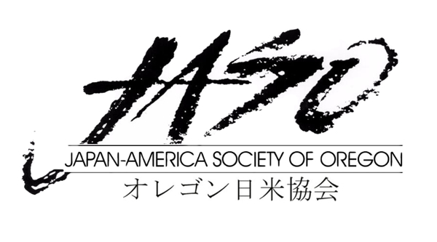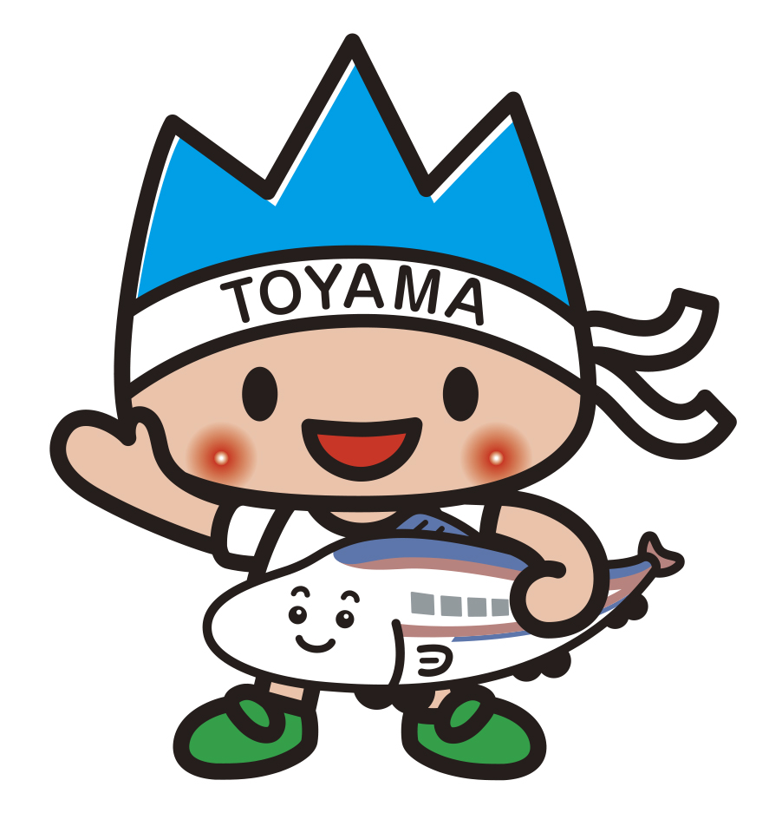富山県

APPLICATION
2021 Online Toyama Cup Speech Contest

(In English) First Name __________________________ Last Name ________________________
(In Japanese) First Name __________________________ Last Name ________________________
Address ______________________________________________________________________________________________

Phone ___________________________ Email ____________________________________________________________

University/College ____________________________________ Teacher __________________________________

Teacher’s Email Address__________________________________________________________________________

Level of Competition ____________________________________

Please check the appropriate box below
☐ I am currently taking a Japanese class in the level of ____________________.
☐ I am NOT currently taking a Japanese class, but conducted a placement interview. I am placed on level of __________.

To instructors: please describe the level of the participant briefly

Signature of the instructor: ＿＿＿＿＿＿＿＿＿＿＿＿＿＿＿＿＿＿＿＿＿＿＿＿

Reason for Participating in the Toyama Cup Speech Contest Page 2

_________________________________________________________________________________________________________

_________________________________________________________________________________________________________

_________________________________________________________________________________________________________

Title of Speech and Summary of Proposed Speech Topic
_________________________________________________________________________________________________________

_________________________________________________________________________________________________________

_________________________________________________________________________________________________________

_________________________________________________________________________________________________________

Toyama Honorary Friendly Envoy Program – This applies only to Level 2 applicant
Please mark Consent or Not Consent

☐ I have read the outline and information on the Toyama Honorary Friendly Envoy Program and consent to fulfilling the responsibilities as stated under “Duties”.

☐ I have read the outline and information on the Toyama Honorary Friendly Envoy Program and do not consent to fulfilling the responsibilities as stated under “Duties”.

Signature _________________________________________________ Date________________________

Please note that by selecting to not consent, you are not qualified to receive the trip to Toyama as a reward. If the Grand Prize winner indicates non-consent on his/her application form, the trip to Toyama as an envoy will be awarded to the runner up.

Application is due on April 1, 2021 via email.

Please complete (type if possible) the application and return by April 1, 2021. After completing the form, scan and email to kmiyanaga@jaso.org
Please make sure that you receive a confirmation email from us.

JASO staff will email to notify you for an orientation prior to the event. Please have your questions ready by then.

Please email us a photo of you by April 1, (preferably a headshot photo) to use at the event.

Thank you for your interest in the Japanese Online Speech Contest.

