2024
7th Annual Pacific Northwest JAPAN BOWL®

STUDY GUIDE
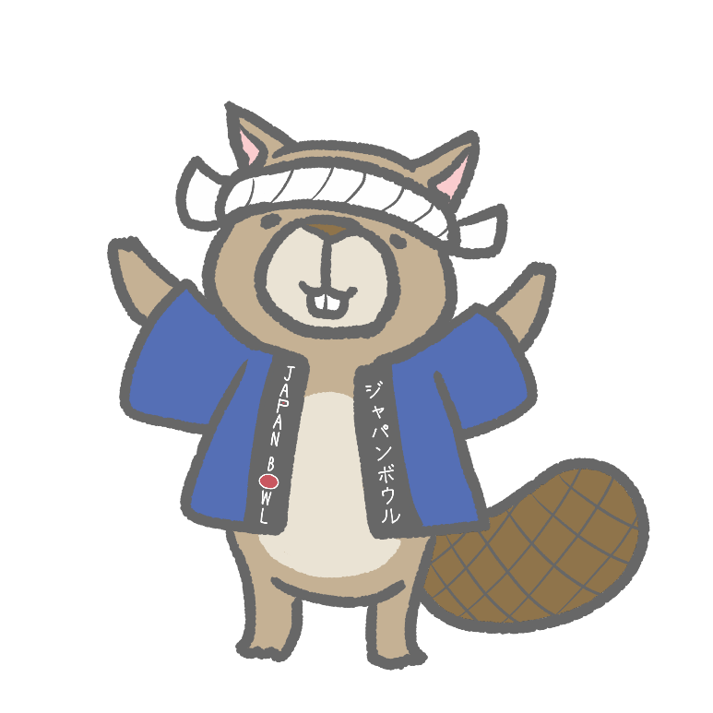©

The Japan-America Society
Of Oregon

Understanding the Japan Bowl Curriculum
ー A Note to Students ー

Welcome to the Pacific Northwest Japan Bowl study guide! We'd like to tell you a little about our curriculum and why it is designed the way it is.

The Pacific Northwest Japan Bowl covers two distinct but interconnected areas: Japanese-language proficiency and content-area knowledge. It is this dual nature of the Japan Bowl curriculum that makes the Japan Bowl unique. We have designed it this way because we are strongly aware that the more familiar you are with Japanese culture, society, history, geography and the arts, the better you will be able to communicate in Japanese.

As you'll see in the study guide that follows, the content-knowledge curriculum is divided between those topics we consider basic, like geography and etiquette, which are covered every year, and others like history or culture that cover more specific content with topics. The language curriculum gives you the chance to use your language skills in real-world situations that require level-appropriate knowledge of kanji, grammar rules, and interpersonal communication skills. It also aims to help you become comfortable with the kind of idiomatic and expressive Japanese that native Japanese speakers commonly use with each other.

Study Guide Table of Contents
Section 1: (pp. 3) Content categories
Section 2: (pp. 5-11) Language categories

Further information:
See http://www.japanbowl.org/resources/ to download a PDF version of the Study Guide and find the Competition Guide for Japan Bowl.

For more information on team and student eligibility requirements, competition rules and format, and preparing for the competition you can visit us at https://jaso.org/japan-bowl/.

CONTENT AREAS – ALL LEVELS

EVERY YEAR: THE BASICS
We’ve adjusted our Nonlanguage topic categories! Geography and Seasons are now part of the
"This Year's Special Topics" section
Manners, Daily Customs and Home Life | Basic manners, etiquette, and daily customs including rights of life etc
Current events | Newsworthy Japan-related events that occurred within the 12 months adding up to the 7th Japan Bowl (April 2023-March 2024)
US-Japan Relations | The relationship between the United States and Japan across all categories
THIS YEAR’S SPECIAL TOPICS
 | 2024
History  Culture, arts, historical figures, and major events | Edo & Meiji Periods  1600-1912
Society  Japanese society and social issues | Trains  Culture, geography, business and vocabulary associated with commercial trains and train lines in Japan.  When studying consider some of the following:  - Culture Ekiben, Shinkansen Cleaning. Tetsukatsu, Commuter & Tourism Passes  - Geography: Major linens, stations and sightseeing trains + train statistics  - Business: Major companies & Organizations; crisis management  - Vocabulary and signage
Culture | Performing Arts & Film  - Traditional Japanese performing arts including popular dance and theatre genres, styles, authors, and examples.  - Japanese cinema since 1899 including major movements, doctors, genres, and examples in Japanese film, including but not limited to Japan Academy Film Prize winning films.
Geography | Natural Geography  - Major bodies of water, mountains, and regions  - Native plant and animal species  - Climate, weather, and common natural disasters
Special topics | Games & Gaming  - Traditional and contemporary Japanese board and card games  - Video games: major developers, companies, and examples. Focus and those games which have won the METI Japan Game Award
Japan’s Regions  Regional Focus  History, geography, regional products and foods, festivals, and cultural heritage sites | Kanagawa & Fukushima Prefectures
Seasons  Seasonal months in literature and culture including national holidays and festivals | Winter

JAPANESE LANGUAGE

The Japan Bowl’s Japanese language categories include those covered every year and those covered on a three-year cycle. In this section you will find the following lists to study:
Material covered every year
- Kanji (basic, practical, family names, place names)
- Measurement Terms
- Aisatsu and Body Language (greetings, useful phrases for social interaction, Gestures )

Material covered over a three-year cycle
- Affective Words
- Verbs with Multiple Meanings
- Yojijukugo
- Giseigo and Gitaigo
- Idioms with Body Parts
- Proverbs

Language lists used every year
Note: Level 2 students should study Level 2 items. Level 3 students should study Levels 2 and 3 items, and Level 4 students, the items in Levels 2, 3 and 4.

Basic Kanji
Level 2: We encourage you to study the kanji not only singly but as parts of words such as 週末, 父母, 米国, 休日, and 何本.
一 | 二 | 三 | 四 | 五 | 六 | 七 | 八 | 九 | 十 | 百 | 千 | 万 | 円 | 日 | 月 | 火 | 水 | 木
金 | 土 | 曜 | 先 | 昨 | 週 | 年 | 今 | 毎 | 何 | 時 | 間 | 午 | 前 | 後 | 分 | 半 | 回 | 末
上 | 下 | 左 | 右 | 人 | 男 | 女 | 父 | 母 | 子 | 家 | 族 | 自 | 姉 | 兄 | 妹 | 弟 | 友 | 本
語 | 学 | 校 | 小 | 中 | 大 | 走 | 生 | 話 | 書 | 見 | 言 | 休 | 行 | 来 | 出 | 入 | 口 | 会
外 | 国 | 駅 | 山 | 川 | 島 | 花 | 草 | 米 | 田 | 文 | 空 | 名 | 止 | 正 | 立 | 私 | 彼 | 英
代 | 広 | 明 | 教 | 室 | 牛 | 犬 | 表 | 主 | 力 | 洋 | 堂 | 工 | 皿 | 声 | 茶 | 枚 | 早
Level 3: We encourage you to study the kanji not only singly but as parts of words such as 気持, 着物, 物語, 生活, and 帰国.
朝 | 昼 | 夕 | 夜 | 春 | 夏 | 秋 | 冬 | 天 | 気 | 雨 | 雪 | 風 | 南 | 北 | 東 | 西 | 方 | 都
県 | 市 | 町 | 区 | 丁 | 村 | 海 | 港 | 所 | 帰 | 寺 | 電 | 車 | 衣 | 食 | 住 | 活 | 品 | 物
着 | 飲 | 料 | 理 | 紙 | 店 | 屋 | 切 | 魚 | 肉 | 起 | 飯 | 耳 | 目 | 手 | 足 | 頭 | 体 | 心
持 | 思 | 元 | 病 | 強 | 弱 | 同 | 和 | 親 | 昔 | 員 | 供 | 以 | 台 | 売 | 買 | 安 | 高 | 低
新 | 古 | 色 | 赤 | 青 | 白 | 黒 | 好 | 銀 | 払 | 勉 | 試 | 験 | 運 | 動 | 聞 | 音 | 楽 | 歌
絵 | 芸 | 術 | 院 | 読 | 結 | 婚 | 野 | 真 | 発 | 的 | 服 | 授 | 貸 | 館 | 宿 | 様 | 計 | 忘
研 | 究 | 内 | 絶 | 対 | 信 | 経 | 配 | 重 | 記 | 守 | 若 | 幸 | 両 | 々(kanji repetition symbol)

Level 4: We encourage you to study the kanji not only singly but as parts of words such as 便利, 歩道, 近代, 最高, and 都市化.
世 | 界 | 地 | 図 | 鉄 | 道 | 旅 | 場 | 線 | 階 | 門 | 戸 | 次 | 当 | 歩 | 通 | 遅 | 引 | 開
閉 | 始 | 終 | 番 | 号 | 待 | 考 | 急 | 決 | 使 | 寒 | 暑 | 遅 | 近 | 遠 | 建 | 由 | 多 | 少
最 | 悪 | 全 | 部 | 用 | 知 | 果 | 作 | 化 | 死 | 卒 | 業 | 仕 | 事 | 映 | 画 | 医 | 者 | 神
社 | 農 | 産 | 漢 | 字 | 科 | 興 | 味 | 習 | 特 | 別 | 有 | 不 | 無 | 非 | 常 | 便 | 利 | 未
長 | 短 | 意 | 働 | 連 | 度 | 留 | 注 | 転 | 借 | 歳 | 題 | 痛 | 残 | 説 | 案 | 顔 | 情 | 悲
怒 | 変 | 比 | 笑 | 相 | 横 | 調 | 査 | 違 | 感 | 答 | 質 | 問 | 続 | 府

Practical Kanji: The following kanji are often used on signs in public places in Japan. It is useful to know what these kanji mean when you see them, even if you cannot pronounce or write them.
LEVEL 2 | 終 as in 終日(しゅうじつ)，終点(しゅうてん)  非 as in 非常口(ひじょうぐち)，非売品(ひばいひん)
LEVEL 3 | 危 as in 危険(きけん)，危ない(あぶない)  禁 as in 立入禁止(たちいりきんし)，厳禁(げんきん)  災 as in 震災(しんさい)，災害(さいがい)
LEVEL 4 | 不 as in 不燃物(ふねんぶつ)，不要不急(ふようふきゅう)  可 as in 可燃物(かねんぶつ)，カード決済可(けっさいか)

Common Family Names: These names turn up so often that you want to be able to pronounce them correctly on sight.
LEVEL 2 | 田中(たなか)，山田(やまだ)，山口(やまぐち)，中村(なかむら)，  木村(きむら)，林(はやし)，本田(ほんだ)
LEVEL 3 | 高橋(たかはし)，山本(やまもと)，松本(まつもと)，松下(まつした)，  井上(いのうえ)，小林(こばやし)，吉田(よしだ)
LEVEL 4 | 佐藤(さとう)，渡辺(わたなべ)，伊藤(いとう)，野村(のむら)，  清水(しみず)，鈴木(すずき)，佐々木(ささき)

Common Place Names: These place names commonly appear on signs and in maps, websites, news stories, manga -- every kind of reading material. It is useful to know where these places are located and how they are pronounced.*
LEVEL 2 | 東京（とうきょう）、京都（きょうと）、大阪（おおさか）、名古屋（なごや）、本州（ほんしゅう）、四国（しこく）、九州（きゅうしゅう）、沖縄（おきなわ）、太平洋（たいへいよう）、日本海（にほんかい）
LEVEL 3 | 神奈川（かながわ），福島（ふくしま）、横浜（よこはま）、川崎（かわさき）、東北（とうほく）、関東（かんとう）、中部（ちゅうぶ）、北陸（ほくりく）、関西（かんさい）、中国（ちゅうごく）
LEVEL 4 | 長崎(ながさき)，神戸(こうべ)，銀座(ぎんざ)，新宿(しんじゅく)，原宿(はらじゅく)，上野(うえの)，秋葉原(あきはばら)，  浅草(あさくさ)
* See also “Geography basics” in the Content-area chart.

Measurement Terms: These are units of measurement commonly used in everyday conversation in Japan. Familiarity with them helps with everything from shopping to making plans to participating in ordinary conversations in Japanese.
LEVEL 2 | Temperature -- Celsius (°C)
LEVEL 3 | Weight -- gram (gr), kilogram (kg)
LEVEL 4 | Length -- centimeter (cm), meter (m), kilometer (km)

Aisatsu: The following expressions are good to know for smooth social interaction.
LEVEL 2 | おやすみなさい  行ってきます  行ってらっしゃい  ただいま  おかえりなさい  ごめんなさい  おげんきですか  はじめまして  よろしくおねがいします
LEVEL 3 | ご入学、おめでとうございます  ごそつぎょう、おめでとうございます  おつかれさまでした  よくいらっしゃいました  おじゃまします  どうぞお入りください  先日はありがとうございました  しつれいしました  おだいじに(してください)  お気をつけて  たのしんできてください
LEVEL 4 | おかげさまで  お先にしつれいします  ごぶさたしています（おります）  無理しないで  もうしわけありません  いつもお世話になっています（おります）  かしこまりました  お待たせしました  それでは、しつれいします  しょうちしました  ご連絡(れんらく)をお待ちしています（おります）  〜によろしくお伝(つた)えください

Language lists on a three-year cycle

Note: As stated earlier, Level 2 students should study Level 2 items. Level 3 students should study Levels 2 and 3 items, and Level 4 students, the items in Levels 2, 3, and 4.

Affective Words: Emotions are expressed differently in different languages. Short words like the ones below can convey all sorts of emotions if used properly.
 | 2024
L2 | うっかり  かなり  すっかり  なんとなく
L3 | そのうち  ばっちり  どうやら  とっさに  なんとか
L4 | あったかも  たいして (〜ない)  そっと  ひょっとしたら

Verbs with Multiple Meanings: The following are examples of common words with multiple meanings that are sometimes differentiated with homophonous kanji. There are many such words in Japanese.
 | 2024
L2 | かさをさす (差す)
L3 | 西日(にしび)がさす (差す)
L4 | 人を指(ゆび)でさす (指す)  将棋(しょうぎ)をさす (指す)

Yojijukugo: Yojijukugo are idioms of four kanji arranged in a meaningful way.
 | 2024
L2 | 一石二鳥 (いっせきにちょう)  日進月歩 (にっしんげっぽ)
L3 | 一部始終 (いちぶしじゅう)  有言実行 (ゆうげんじっこう)
L4 | 前代未聞 (ぜんだいみもん)  完全無欠 (かんぜんむけつ)

Giseigo and Gitaigo: Giseigo refers to animal and human sounds (e.g., chirping, laughing) while gitaigo are used to describe a certain state (e.g., facial expression, atmosphere).
 | 2024
All  levels | うきうき  うっとり  おろおろ  くっきり  ごろごろ  さらさら  どきどき  どんどん  ぱっと  はっきり  もぐもぐ  よれよれ

Idioms with Body Parts: Many Japanese idioms like these refer to body parts and are used in everyday conversation.
 | 2024
L2 | 気が短い (きがみじかい)  耳が痛い (みみがいたい)  目を丸くする (めをまるくする)
L3 and L4 | 足が棒になる (あしがぼうになる)  頭が上がらない (あたまがあがらない)  肩を持つ (かたをもつ)  腰が重い (こしがおもい)
Proverbs: Proverbs are an integral part of all languages and cultures, and Japanese is no exception.
 | 2024
L2 | 鬼に金棒 (おににかなぼう)  月とすっぽん (つきとすっぽん)
L3 | 石の上にも三年 (いしのうえにもさんねん)  好きこそものの上手なれ (すきこそもののじょうずなれ)  縁の下の力持ち (えんのしたのちからもち)
L4 | 雨降って地固まる (あめふってじかたまる)  言わぬが花 (いわぬがはな)  帯に短し、たすきに長し (おびにみじかし、たすきにながし)  かわいい子には旅をさせよ (かわいいこにはたびをさせよ)  光陰矢のごとし (こういんやのごとし)  鉄は熱いうちに打て (てつはあついうちにうて)  所変われば品変わる (ところかわればしなかわる)  逃がした魚は大きい (にがしたさかなはおおきい)  喉元過ぎれば、熱さを忘れる（のどもとすぎれば、あつさをわすれる)

