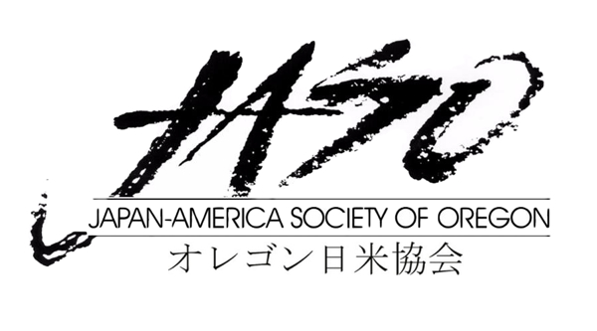富山県

**APPLICATION**

**2025 Online Toyama Cup Speech Contest**

**(In English) First Name ____________________ Last Name ____________________**

**(In Japanese) First Name ____________________ Last Name______________________**

**Home Address (Where we can send a certificate)**  **___________________**

**Cell Phone____________________**__ **Email Address** **____________________**

**University/College** __ **____________________ Teacher’s Name**   **____________________**

**Teacher’s Email Address ____________________**

**Level of Competition ____________________**

**Please check the appropriate box below**

**I am currently taking a Japanese class in the level of ____________________ .**

**I am NOT currently taking a Japanese class, but conducted a placement interview. I am placed on level of ____________________.**

To instructors: please describe the level of the participant briefly

Click or tap here to enter text.

Signature of the instructor: ＿**____________________**

**Reason for Participating in the Toyama Cup Speech Contest Page 2**

Click or tap here to enter text.

**Title of Speech and Summary of Proposed Speech Topic**

Click or tap here to enter text.

**Toyama Honorary Friendly Envoy Program – This applies only to Level 2 applicant**

**Please mark Consent or Not Consent**

I have read the outline and information on the Toyama Honorary Friendly Envoy Program and consent to fulfilling the responsibilities as stated under “Duties”.

I have read the outline and information on the Toyama Honorary Friendly Envoy Program and **do not** consent to fulfilling the responsibilities as stated under “Duties”.

Signature _________________________________________________ Date________________________

*Please note that by selecting to not consent, you are not qualified to receive the trip to Toyama as a reward. If the Grand Prize winner indicates non-consent on his/her application form, the trip to Toyama as an envoy will be awarded to the runner up.*

Please complete this application by **April 1, 2025** and email it to Kaoru Miyanaga at [**kmiyanaga@jaso.org**](mailto:kmiyanaga@jaso.org)

Please make sure that you receive a confirmation email from us within few days.

JASO staff will email to notify you for an orientation prior to the event. Please have your questions ready by then.

**Also please email Kaoru your headshot photo by April 1,** to use for the event.

Thank you for your interest in the Japanese Online Speech Contest.