2026 Online 30th Toyama Cup – Japanese Speech Contest
第30回【富山カップ】日本語スピーチコンテスト(オンライン)

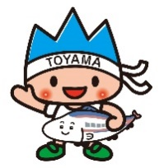

Background of Contest:

In 1996, Toyama Prefecture and the State of Oregon started collaboration with the Japan-America Society of Oregon to partner in presenting a speech contest for university and college students studying Japanese in Oregon and Southwest Washington. Oregon has enjoyed a sister-state/prefecture relationship with Toyama since 1991 and the speech contest was held in celebration of the 5^{t}year of this relationship, in 1996. This will be the 30th Toyama Cup Japanese Speech Contest.

Purpose: To build a stronger relationship between the peoples of Toyama and Oregon by promoting Japanese language education in Oregon and Southwest Washington universities and colleges.

Date and Time: Saturday, April 25, 2026, from 4pm to 7pm (Oregon Time)

Location: Online, Zoom

Eligibility: Any non-native speaker of Japanese undergraduate student studying Japanese at a college (community colleges included) or university in the State of Oregon or Southwest Washington. Students who are currently NOT taking a Japanese course also may participate in the event. In that case, the instructor of each school is to conduct a simple placement interview to decide on the appropriate level and sign the application form. Please also describe the case in the form briefly (ex. 1 The applicant is currently not taking any Japanese class due to a schedule conflict, but they finished JPN201 last term and their proficiency is about the second year level.)
If the applicant is in a unique situation, please also describe the case in the form briefly. (ex.2 The applicant is placed into level 1 due to their writing proficiency is 100 level, however, their speaking proficiency is much higher because they are an immersion learner. Hence it seems more appropriate for this applicant to compete in the upper level, etc).

Levels of Competition:

- Level 1: Any student who is currently in (or placed on) 100 and 200 level Japanese class

- Level 2: Any student who is currently in (or placed on) 300 and 400 level Japanese class

Prizes:

- Level 1: Top 3 will receive gifts including Japanese books, a medal and certificate from Toyama Prefecture. 1st place winner will receive a Toyama’s local traditional craft item.

- Level 2: Top 3 will receive gifts from Toyama Prefecture. The winner also receives a trip to Toyama Prefecture. By accepting the trip, the winner agrees to become a designated “Honorary Friendly Envoy” as described separately. This trip will be scheduled accordingly no late than December, 2026. If you think you are unable to go, please JASO know in advance.

Please complete your application by April 3, 2026, and email it to Kaoru Miyanaga at kmiyanaga@jaso.org

Ensure that you receive a confirmation email from us within a few days to verify that your application has been received.

JASO staff will send an email to notify you of an orientation prior to the event. Please be prepared with any questions you may have.

Additionally, kindly email Kaoru a headshot photo by April 3 to be used for the event.

Speech Topic and Length

Speeches should be at least 3 minutes but no more than 5 minutes in length.

Contestants are free to select a topic that they are passionate about and speak authentically about it.

Examples might include:
- Personal story
- Why I study Japanese
- My future career plan
- The Importance of Sister-City and Sister State Relationships (such as the Toyama-Oregon Sister State affiliation).
- Japan-Related Experiences
- Environmental issues
- International relations

Scoring and Criteria are based on the following:

Language Proficiency |  |  | Content and Creativity  (10) | Presentation  (10) | Question and Answer
Utterance Smoothness and speed/pace (5) | Pronunciation and Intonation (5) | Grammatical Ability  (10) | Content and Creativity  (10) | Presentation  (10) | Listening comprehension (5) | Spontaneous response and originality (5)
(5)  ・Very smooth  (no unnatural pauses)  ・Recovers almost every time | (5)  Native-like pronunciation | (10)  Almost always use the correct Japanese grammar and vocabulary | (10)  ・Very original content  ・Organized well | (10)  ・Full of confidence  ・Almost no use of the notes (just checking)  ・effective eye contact and gesture | (5)  Always comprehended well (no slow down or repeat) | (5)  ・Very spontaneous & coherent  ・original content

Questions and Answers

Each contestant will be asked 2 questions in Japanese by a designated judge. An audience member may also ask an additional 1-2 questions (only judges’ questions will be scored).

NOTE: Students will have at least one meeting with JASO staff prior to the speech contest.

Participants will have a networking time with college students and others from Toyama Prefecture.
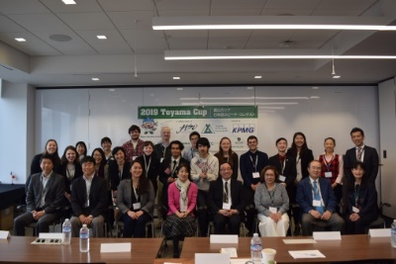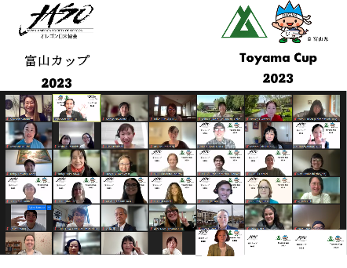

Presentation from the past winners of Toyama Cup:

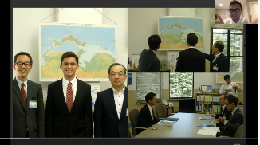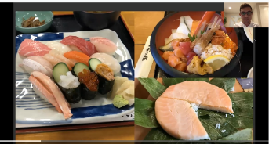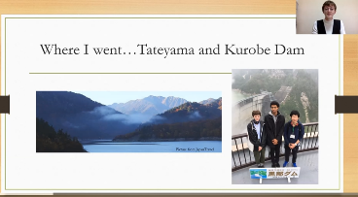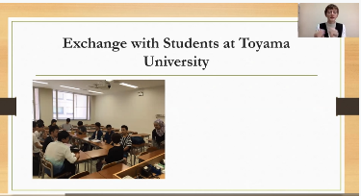

Timeline for the Day of Toyama Cup
4:00-4:15 PM
Welcome by the Executive Director of JASO
Introduction of the judges
4:25-5:00 PM
Level 1 Speech starts
5:10-5:45 PM
Level 2 Speech starts
5:45-5:50 PM
Presentations by the 2025 Toyama Cup Winner
5:50-6:30 PM
Networking Breakout Session with Toyama Students
6:30-7:00 PM
Presentation of Awards
Event concludes
The timeline may vary depending on the number of participants.

Outline of the Toyama Honorary Friendly Envoy Program

PURPOSE
- Toyama Prefecture has established the “Toyama Honorary Friendly Envoy” program in order to establish and strengthen relations with other countries.

REQUIREMENTS FOR THE NOMINATION OF ENVOYS
- Toyama Prefecture will nominate any non-native individuals to be envoy who meet the following requirements or those who are approved by the governor.
- Individuals who are interested in fostering international relations and understanding, and who have worked to promote exchange with the citizens of Toyama Prefecture, through the following activities, during their stay in Toyama Prefecture.
- Participation in international activities.
- Introduced and helped enhance interest in other countries in the citizens of Toyama Prefecture.
- Gained a deep understanding of Toyama Prefecture and its citizens.
- Voluntarily participated in international exchange events, etc.
- Helped nurture and strengthen relations among foreigners, and relations between native Japanese and foreigners residing in Toyama Prefecture.
- Individuals whom we can expect to inform others about Toyama Prefecture and its citizens through their activities in both Japan and overseas.
- Individuals who will or have obtained a functional command of the Japanese language.
- Individuals who have stayed, or intend to stay, in Toyama Prefecture for 1 or more years. However, permanent residents shall not qualify for this program.

HOW THE ENVOYS ARE CHOSEN
- The governor shall select envoys from a number of candidates to be recommended by the International Exchange Organization and other relevant organizations.

FORFEIT OF THE TITLE
- If the envoy cannot fulfill the requirements hereby outlined, or he/she becomes ineligible to serve as an envoy, he/she must promptly render the title back to Toyama Prefecture.

GRANTING OF THE TITLE
- The governor of Toyama Prefecture will present to all appointed envoys a plaque and a memorial gift.

DUTIES
- The duties of the envoy are as follow:
- Envoys should try to introduce Toyama to other people, and provide advice to Toyama Prefecture in order to help promote international exchanges between Toyama and other countries. They will also act as a liaison between Toyama and overseas countries.
- Envoys should try to associate with foreigners living in Japan, and make an effort to introduce to them the various kinds of information that they have collected on Toyama.
- Envoys should support the promotion of international exchange activities in Toyama as much as they can, and should attempt to associate with the people of Toyama if they have the opportunity to visit or stay in Toyama again.
- Envoys should send regular reports updating Toyama Prefecture on their status and respond to requests from Toyama Prefecture for their impression of Toyama Prefecture (messages are also acceptable).
- Envoys should also send information about their countries when Toyama Prefecture makes a request. Toyama Prefecture also requires the envoy’s assistance if we send a delegation to his/her country.

DISPATCH OF PUBLISHED MATERIALS
- We will periodically send published materials to envoys in order to ensure that they have up-to-date information about Toyama Prefecture.
Pictures from past winners’ experience
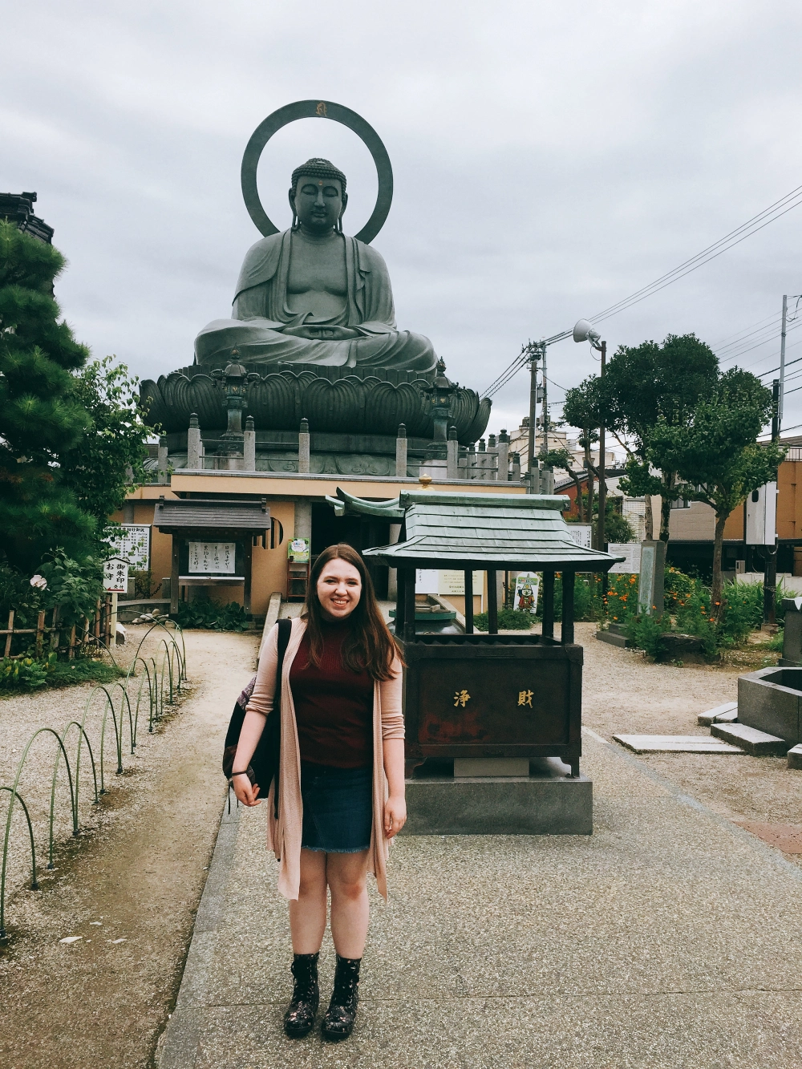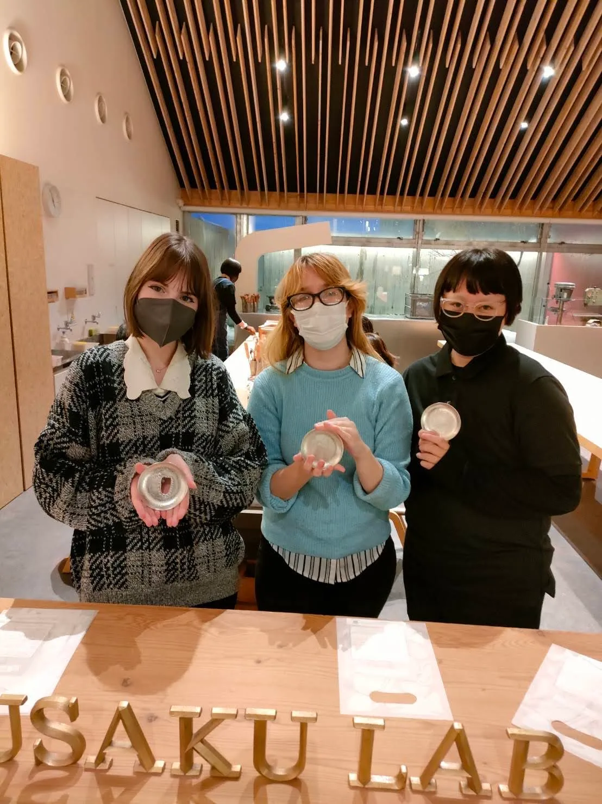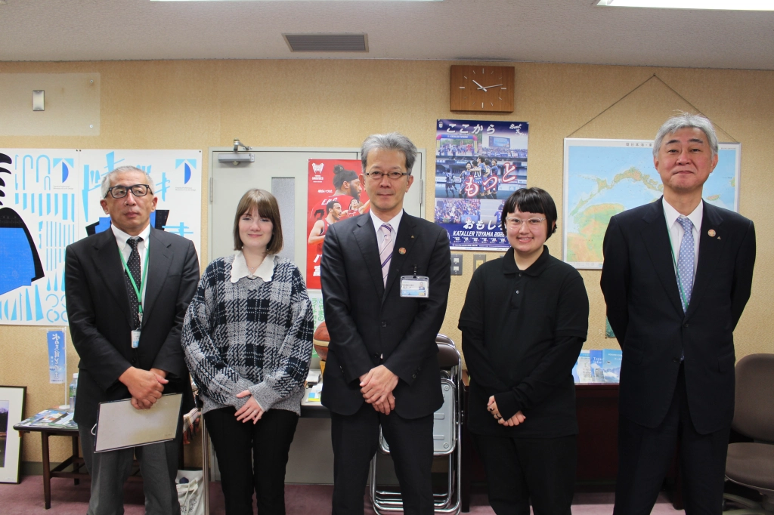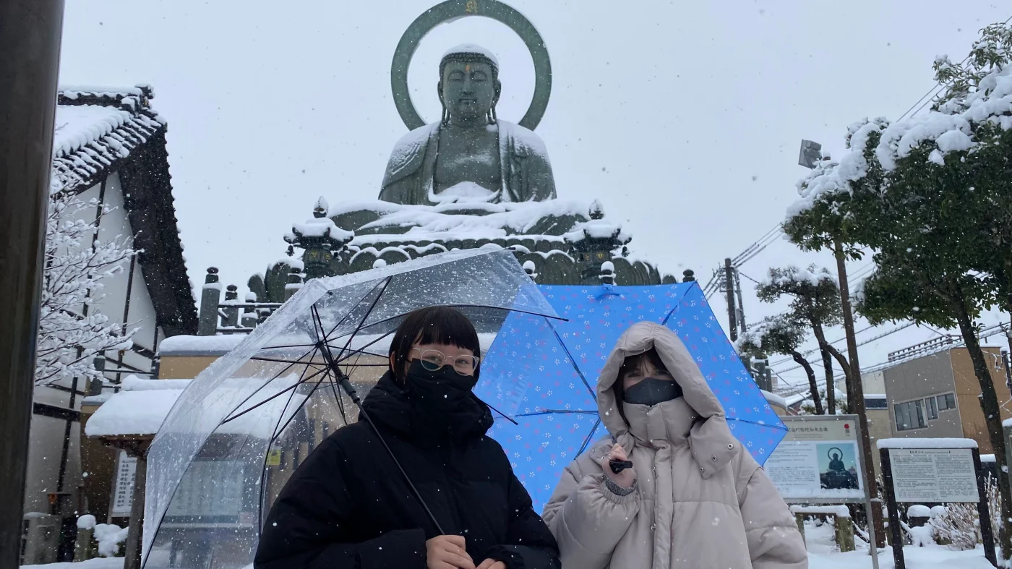
Toyama Prefecture
