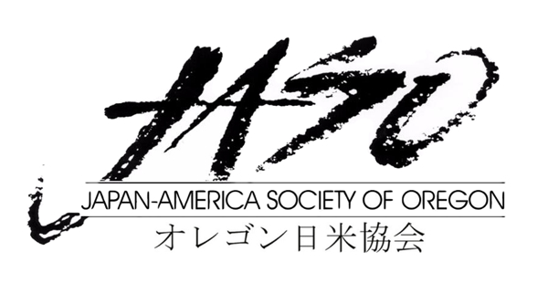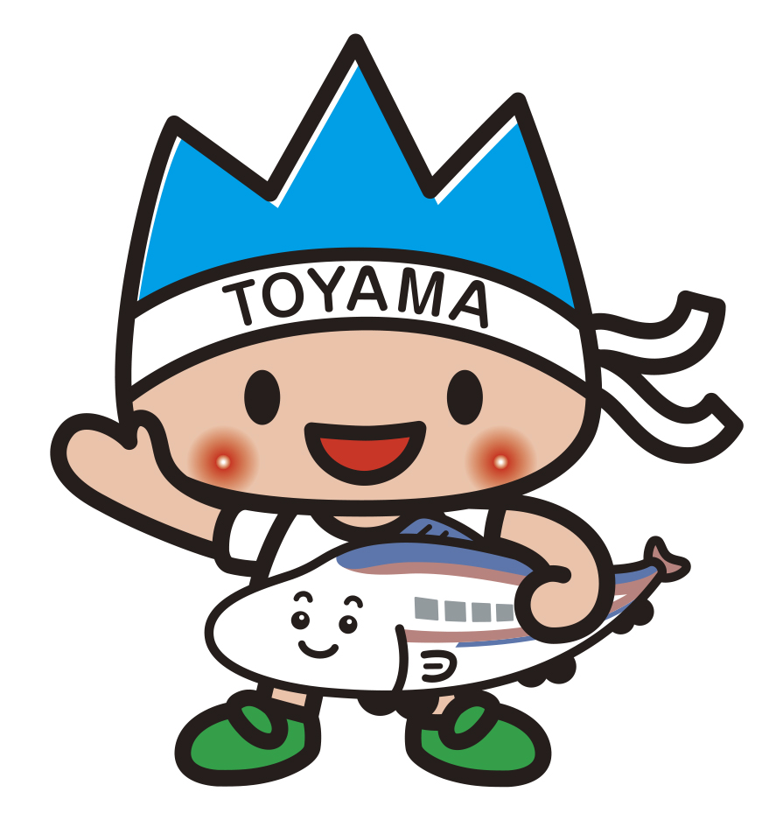富山県

APPLICATION
2026 Online Toyama Cup Speech Contest

(In English) First Name ____________________ Last Name ____________________
(In Japanese) First Name ____________________ Last Name______________________
Home Address (Where we can send a certificate) ___________________

Cell Phone______________________ Email Address ____________________

University/College __ ____________________ Teacher’s Name ____________________

Teacher’s Email Address ____________________

Level of Competition ____________________

Please check the appropriate box below
☐ I am currently taking a Japanese class in the level of ____________________ .
☐ I am NOT currently taking a Japanese class, but conducted a placement interview. I am placed on level of ____________________.

To instructors: please describe the level of the participant briefly

Click or tap here to enter text.

Signature of the instructor: ＿____________________

Reason for Participating in the Toyama Cup Speech Contest Page 2
Click or tap here to enter text.

Title of Speech and Summary of Proposed Speech Topic
Click or tap here to enter text.

Toyama Honorary Friendly Envoy Program – This applies only to Level 2 applicant

Please mark Consent or Not Consent

☐ I have read the outline and information on the Toyama Honorary Friendly Envoy Program and consent to fulfilling the responsibilities as stated under “Duties”.

☐ I have read the outline and information on the Toyama Honorary Friendly Envoy Program and do not consent to fulfilling the responsibilities as stated under “Duties”.

Signature _________________________________________________ Date________________________

Please note that by selecting to not consent, you are not qualified to receive the trip to Toyama as a reward. If the Grand Prize winner indicates non-consent on his/her application form, the trip to Toyama as an envoy will be awarded to the runner up.

Please complete this application by April 6, 2026 and email it to Kaoru Miyanaga at kmiyanaga@jaso.org
Please make sure that you receive a confirmation email from us within few days.

JASO staff will email to notify you for an orientation prior to the event. Please have your questions ready by then.

Also please email Kaoru your headshot photo by April 6, to use for the event.

Thank you for your interest in the Japanese Online Speech Contest.

