2027
10th Annual Pacific Northwest JAPAN BOWL®

STUDY GUIDE
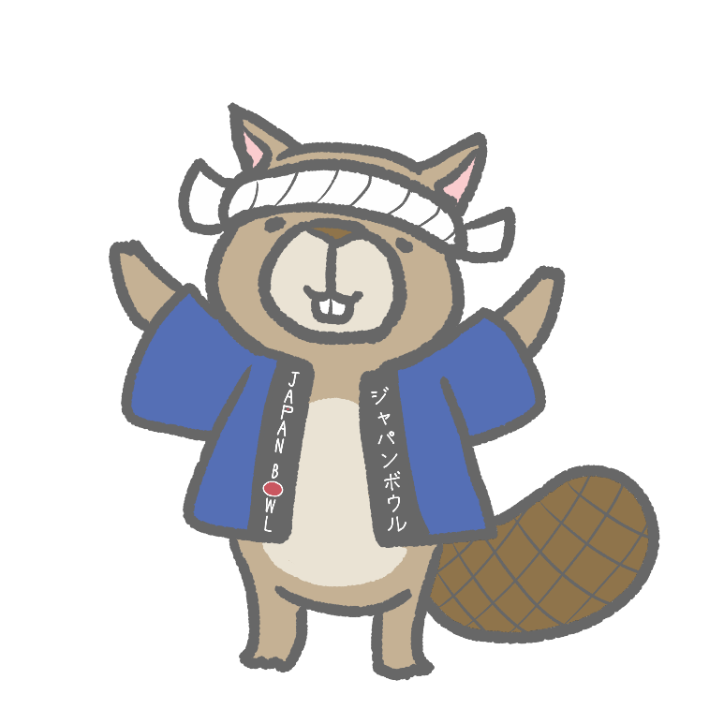©

The Japan-America Society
Of Oregon

Table of Contents

Change Log - What’s new at the Japan Bowl 2
Understanding the Japan Bowl Curriculum 3
CONTENT TOPICS – ALL LEVELS 4
EVERY YEAR: THE BASICS 5
In-Depth Topics 6
JAPANESE LANGUAGE 7
Basic Kanji 7
Practical Kanji 9
Common Family Names 9
Common Place Names 10
Verbs with Multiple Meanings 10
Aisatsu, Aizuchi, and Shigusa 11
Giseigo and Gitaigo 11
Affective Words 12
Idioms 13
Yojijukugo 14
Proverbs 15
Measurement Terms 16

Change Log - What’s new at the 10th Pacific Northwest Japan Bowl and 35th National Japan Bowl

- The Aisatsu, Aizuchi, and Shigusa section (previously “Useful Expressions”) has been updated.
- The Common Place Names list has been updated. Please review the new list carefully.

Understanding the Japan Bowl Curriculum
ー A Note to Students ー

Welcome to the Pacific Northwest Japan Bowl study guide! We'd like to tell you a little about our curriculum and why it is designed the way it is.

The Pacific Northwest Japan Bowl covers two distinct but interconnected areas: Japanese-language proficiency and content-area knowledge. It is this dual nature of the Japan Bowl curriculum that makes the Japan Bowl unique. We have designed it this way because we are strongly aware that the more familiar you are with Japanese culture, society, history, geography and the arts, the better you will be able to communicate in Japanese.

As you'll see in the study guide that follows, the content-knowledge curriculum is divided between those topics we consider basic, like geography and etiquette, which are covered every year, and others like history or culture that cover more specific content with topics. The language curriculum gives you the chance to use your language skills in real-world situations that require level-appropriate knowledge of kanji, grammar rules, and interpersonal communication skills. It also aims to help you become comfortable with the kind of idiomatic and expressive Japanese that native Japanese speakers commonly use with each other.

Further information:

For more information on team and student eligibility requirements, competition rules and format, and preparing for the competition you can visit us at https://jaso.org/japan-bowl/.

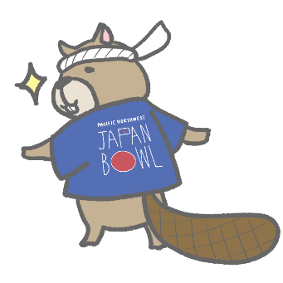©

CONTENT TOPICS – ALL LEVELS

EVERY YEAR: THE BASICS
Etiquette at school, in public places, and as a guest in people's homes
Annual holidays and rites of life
Newsworthy events of the year (May 2026 to April 2027) related to Japan or to US-Japan relations

At the 10th Pacific Northwest Japan Bowl, you will be quizzed only on the materials in the 2027 column.
3-YEAR CURRICULUM TOPICS
 |  | 2027 | 2028 | 2029
Geography |  | Regional Geography, Climate, and Natural Disasters  - Climate zones  - Weather patterns  - Earthquakes, typhoons, tsunamis, etc. | Physical geography and natural features | Prefectures, cities, and agriculture
History |  | 1600-1912  Edo and Meiji periods  - Major historical figures and events  - Major political and economic developments  - Major cultural and social developments | 1912 – Present  Taisho through Reiwa periods | 710 – 1600  Nara through Sengoku periods
Arts and Culture |  | Architecture and Gardens  Premodern and modern  - Major styles  - Major examples  - Major architects and landscape architects | Literature, Theater, and Film | Visual arts
Society and Social Issues |  | Environmental issues and policies  - Climate change  - Environmental disasters  - Sustainability | Demography and demographic issues | Japan and the International Economy

In-Depth Topics
2027 Locality | Kōchi Prefecture  - Geography and history  - Major local products and foods  - Major figures: Nakahama Manjirō (John Manjirō), Sakamoto Ryōma, Itagaki Taisuke, and Kusunose Kita  - Major festivals, cultural heritage designations, and UNESCO sites
2027 Deep Dive | Ōzumō: Three “T”s of Professional Sumo  - Training: the stable system, rankings, and basics  - Traditions: the ring, attire, and names  - Tournaments: venues, rules, and ceremonies  Please also study the vocabulary listed below, cumulative by level:  - Vocab  - Level 2  - Basho  - Chanko-nabe  - Mage  - Mawashi  - Oyakata  - Rikishi  - Level 3  - Dohyō-iri  - Sumōbeya  - Yokozuna - (Hakuho and Akebono, famous foreign yokozuna)  - Yūshō  - Level 4  - Banzuke  - Gyōji  - Keshō-mawashi

JAPANESE LANGUAGE

Every year, many of the Japan Bowl's language questions address listening comprehension skills and language use in context. The Japanese-language categories covered in the Japan Bowl also include the material in the following lists:

- Kanji (basic, practical, family names, place names)
- Verbs with Multiple Meanings
- Aisatsu, Aizuchi, and Shigusa
- Giseigo and Gitaigo
- Affective Words
- Idioms
- Yojijukugo
- Proverbs
- Measurement Terms

IMPORTANT NOTE: For all materials in this Study Guide, Level 2 students should study Level 2 items, Level 3 students should study Level 2 and 3 items, and Level 4 students should study all Levels’ items.
Please use the following color code to guide your studies:
Level 2 Level 3 Level 4

Basic Kanji
We encourage you to study the kanji not only singly but as parts of words such as (LV 2) 週末, 父母, 米国, 時代, 何本; (LV 3) 料理, 物語, 生活, 南北; and (LV 4) 便利, 歩道, 中世, 戦国.
Level 2
一 | 二 | 三 | 四 | 五 | 六 | 七 | 八 | 九 | 十 | 百 | 千 | 万 | 円 | 日 | 月 | 火 | 水 | 木
金 | 土 | 曜 | 先 | 昨 | 週 | 年 | 今 | 毎 | 何 | 時 | 間 | 午 | 前 | 後 | 分 | 半 | 回 | 末
上 | 下 | 左 | 右 | 人 | 男 | 女 | 父 | 母 | 子 | 家 | 族 | 自 | 姉 | 兄 | 妹 | 弟 | 友 | 本
語 | 学 | 校 | 小 | 中 | 大 | 走 | 生 | 話 | 書 | 見 | 言 | 休 | 行 | 来 | 出 | 入 | 口 | 会
外 | 国 | 駅 | 山 | 川 | 島 | 花 | 草 | 米 | 田 | 文 | 空 | 名 | 止 | 正 | 立 | 私 | 彼 | 英
代 | 広 | 明 | 教 | 室 | 牛 | 犬 | 表 | 主 | 力 | 洋 | 堂 | 工 | 皿 | 声 | 茶 | 枚 | 早

Level 3
朝 | 昼 | 夕 | 夜 | 春 | 夏 | 秋 | 冬 | 天 | 気 | 雨 | 雪 | 風 | 南 | 北 | 東 | 西 | 方 | 都
県 | 市 | 町 | 区 | 丁 | 村 | 海 | 港 | 所 | 帰 | 寺 | 電 | 車 | 衣 | 食 | 住 | 活 | 品 | 物
着 | 飲 | 料 | 理 | 紙 | 店 | 屋 | 切 | 魚 | 肉 | 起 | 飯 | 耳 | 目 | 手 | 足 | 頭 | 体 | 心
持 | 思 | 元 | 病 | 強 | 弱 | 同 | 和 | 親 | 昔 | 員 | 供 | 以 | 台 | 売 | 買 | 安 | 高 | 低
新 | 古 | 色 | 赤 | 青 | 白 | 黒 | 好 | 銀 | 払 | 勉 | 試 | 験 | 運 | 動 | 聞 | 音 | 楽 | 歌
絵 | 芸 | 術 | 院 | 読 | 結 | 婚 | 野 | 真 | 発 | 的 | 服 | 授 | 貸 | 館 | 宿 | 様 | 計 | 忘
研 | 究 | 内 | 絶 | 対 | 信 | 経 | 配 | 重 | 記 | 守 | 若 | 幸 | 両 | 々(kanji repetition symbol)

Level 4
世 | 界 | 地 | 図 | 鉄 | 道 | 旅 | 場 | 線 | 階 | 門 | 戸 | 次 | 当 | 歩 | 通 | 遅 | 引 | 開
閉 | 始 | 終 | 番 | 号 | 待 | 考 | 急 | 決 | 使 | 寒 | 暑 | 戦 | 近 | 遠 | 建 | 由 | 多 | 少
最 | 悪 | 全 | 部 | 用 | 知 | 果 | 作 | 化 | 死 | 卒 | 業 | 仕 | 事 | 映 | 画 | 医 | 者 | 神
社 | 農 | 産 | 漢 | 字 | 科 | 興 | 味 | 習 | 特 | 別 | 有 | 不 | 無 | 非 | 常 | 便 | 利 | 未
長 | 短 | 意 | 働 | 連 | 度 | 留 | 注 | 転 | 借 | 歳 | 題 | 痛 | 残 | 説 | 案 | 顔 | 情 | 悲
怒 | 変 | 比 | 笑 | 相 | 横 | 調 | 査 | 違 | 感 | 答 | 質 | 問 | 続 | 府

Practical Kanji
The following kanji are often used on signs in public places in Japan. It is useful to know what these kanji mean when you see them, even if you cannot pronounce or write them.

LEVEL 2 | しゅうじつ しゅうてん  終 as in 終日, 終点  ひじょうぐち ひばいひん  非 as in 非常口, 非売品
LEVEL 3 | きけん あぶ  危 as in 危険，危ない  たちいりきんし げんきん  禁 as in 立入禁止, 厳禁  しんさい さいがい  災 as in 震災, 災害
LEVEL 4 | ふねんぶつ ふざい  不 as in 不燃物, 不在  かねんぶつ けっさいか  可 as in 可燃物, カード決済可

Common Family Names
These names turn up so often that you want to be able to pronounce them correctly on sight.

LEVEL 2 | たなか やまだ やまぐち なかむら  田中 山田 山口 中村  きむら はやし ほんだ  木村 林 本田
LEVEL 3 | たかはし やまもと まつもと まつした  高橋 山本 松本 松下  いのうえ こばやし よしだ  井上 小林 吉田
LEVEL 4 | さとう わたなべ いとう のむら  佐藤 渡辺 伊藤 野村  しみず すずき ささき  清水 鈴木 佐々木

Common Place Names
These place names commonly appear on signs and in maps, websites, news stories, manga -- every kind of reading material. It is useful to know where these places are located and how they are pronounced.

LEVEL 2 | ほっかいどう ほんしゅう しこく きゅうしゅう おきなわ  北海道 本州 四国 九州 沖縄  とうきょう おおさか きょうと  東京 大阪 京都
LEVEL 3 and  LEVEL 4 | こうちけん こうちし にほんかい たいへいよう  高知県 高知市 日本海 太平洋  せとないかい ひろしま なごや よこはま さっぽろ ふくおか  瀬戸内海 広島 名古屋 横浜 札幌 福岡

Verbs with Multiple Meanings
Many common words in Japanese have multiple meanings that sound the same but that are written with different kanji. One example is さす:

LEVEL 2 and  LEVEL 3 | さ さ にしび さ  差す → かさを差す 西日が差す
LEVEL 4 | さ ゆび さ しょうぎ さ  指す → 人を指で指す 将棋を指す

Aisatsu, Aizuchi, and Shigusa
You are already familiar with many greetings (aisatsu), set phrases used in daily life, and expressions (aizuchi) and body language (shigusa) that facilitate social interaction. As you’re studying, you might find it useful to keep a running list, but here are some examples to start.

ALL LEVELS | Aisatsu: どうぞ、おじゃまします、おかげさまで  Aizuchi: やったー、あのう、なるほど、たいへん  Shigusa: bowing, beckoning wave, pointing at your nose

Giseigo and Gitaigo
Giseigo refer to animal and human sounds (e.g., chirping, laughing) while gitaigo describe a certain state (e.g., facial expression, atmosphere).

ALL LEVELS | うきうき どきどき  うっとり どんどん  おろおろ はっきり  ごろごろ もぐもぐ  さらさら よれよれ

Affective Words
Emotions are expressed differently in different languages. Short words like the ones below can convey all sorts of emotions if used properly.

LEVEL 2 | うっかり  かなり  すっかり  なんとなく
LEVEL 3 | そのうち  ばっちり  どうやら  とっさに  なんとか
LEVEL 4 | あたかも  たいして(〜ない)  そっと  ひょっとしたら

Idioms
Many common Japanese idioms, including the ones below, refer to body parts and are used in everyday conversation.

LEVEL 2 | き みじか  気が短い  みみ いた  耳が痛い  め まる  目を丸くする
LEVEL 3  and  LEVEL 4 | あし ぼう  足が棒になる  あたま あ  頭が上がらない  かた も  肩を持つ  こし おも  腰が重い  はら き  腹を決める  は く  歯を食いしばる  みみ うたが  耳を疑う

Yojijukugo
Yojijukugo are idioms consisting of four kanji.

LEVEL 2 | いっせきにちょう  一石二鳥  にっしんげっぽ  日進月歩
LEVEL 3 | いちぶしじゅう  一部始終  ゆうげんじっこう  有言実行
LEVEL 4 | ぜんだいみもん  前代未聞  かんぜんむけつ  完全無欠

Proverbs
Proverbs are an integral part of all languages and cultures, and Japanese is no exception.

LEVEL 2 | おに かなぼう  鬼に金棒  つき  月とすっぽん
LEVEL 3 | いそ まわ  急がば回れ  いし うえ さんねん  石の上にも三年  す じょうず  好きこそものの上手なれ
LEVEL 4 | こういんや  光陰矢のごとし  あめふ じかた  雨降って地固まる  てつ あつ う  鉄は熱いうちに打て  ところか しなか  所変われば品変わる  に さかな おお  逃がした魚は大きい  おび みじか なが  帯に短し、たすきに長し  こ たび  かわいい子には旅をさせよ

Measurement Terms
These are units of measurement commonly used in everyday conversation in Japan. Familiarity with them helps with everything from shopping to making plans to participating in ordinary conversations in Japanese.

LEVEL 2 | Temperature: Celsius (°C)
LEVEL 3 | Weight: gram (g), kilogram (kg)
LEVEL 4 | Length: centimeter (cm), meter (m), kilometer (km)

